**Capstone Project Name :Product Dissection for Linkedin**

**Name : Advait Kajarekar**

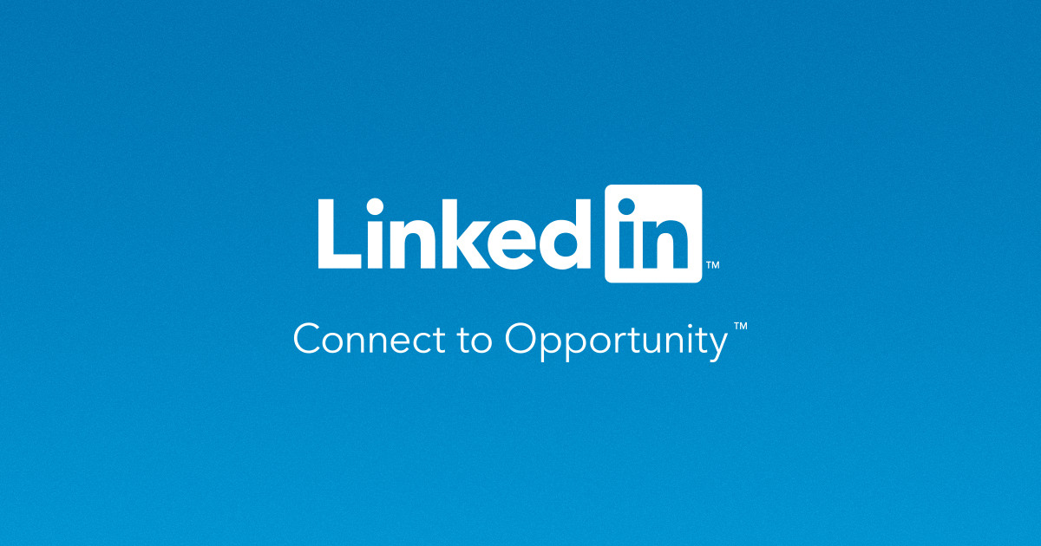

**Product Dissection for Linkedin:**

### **Company Overview:**

LinkedIn began in co-founder [**Reid Hoffman's**](https://www.linkedin.com/in/reidhoffman/?src=or-search&veh=www.google.com) living room in 2002 and was officially launched on May 5, 2003.

Today, LinkedIn leads a diversified business with revenues from membership subscriptions, advertising sales and recruitment solutions under the leadership of [**Ryan Roslansky**](https://www.linkedin.com/in/ryanroslansky/?src=or-search&veh=www.google.com). In December 2016, Microsoft completed its acquisition of LinkedIn, bringing together the world’s leading professional cloud and the world’s leading professional network.

### **Product Dissection and Real-World Problems Solved by Linkedin:**

LinkedIn is, at its foundation, a professional network. Instead of a “social graph” like Facebook, it has a “professional network” or “economic graph” representing relationships people in the professional world. As a node in the network, each member is associated with his or her professional identity. Edges in the network connect people based on their professional relationships: colleagues, classmates, clients, etc.

Or at least that’s the theory. In practice, the network is diluted because many people aggressively add connections to people whom they barely know — and sometimes to people they don’t know at all. Moreover, LinkedIn hasn’t exactly discouraged this practice, instead pursuing an aggressive growth strategy.

But just like Facebook is more than just its social graph, LinkedIn is more than just its professional network. LinkedIn is a collection of products built on top of that network. These include:

* Tools for recruiting employees, particularly passive candidates who aren’t actively seeking employment.
* Tools to help active job seekers find jobs.
* Tools for sales people to find and connect to prospects.
* A feed for people to stay in touch with their professional networks by sharing and consuming content.

LinkedIn does some things better than others. In particular, it’s been more successful as a hiring platform than as a content destination. Regardless, LinkedIn is unique as an online professional network, and it has established itself as a must-have tool for anyone who hires, markets, or sells.

In conclusion, Linkedin's product design has successfully tackled real-world problems by creating a platform that help active job seekers find jobs, fosters connections, and offers Tools for recruiting employees, particularly passive candidates who aren’t actively seeking employment and a feed for people to stay in touch with their professional networks by sharing and consuming content. Through its diverse features,Linkedin addresses the need for authentic engagement, content curation, and meaningful discovery, shaping the digital landscape and providing practical solutions to the evolving needs of its global user base.

### **Case Study: Real-World Problems and Linkedin's Innovative Solutions:**

#### **Problem 1: Reaching out to recruiters**

In this today’s world of cut-throat competition , reaching out to the recruiter is far difficult cause many job seekers are trying to reach out to them.Job seekers usually e-mail their CVs Many job seekers get ignored in this process.

**Linkedin’s Solution** :

Nowadays many recruiters are active on Linkedin. So job seekers can easily reach out to them using cold emailing as well as direct messaging feature of Linked in. He can display his digital tech presence more easily and get their interview scheduled.

**Problem 2: Reaching out to job seekers**

For mere 3-5 vacancies , recruiter has to go through 1000s of resumes and cover letters which is time consuming and most of the times an more skilled job seeker gets ignored or unnotice.

**Linkedin’s Solution** :

Linkedin has a special feature called job post.So recruiter can post it on linked in about vacancies in company and so people can actually apply and its easy to filter out job application based on profile of the applicant. Recruiter can also reach out to the applicants individually.

**Problem 3: Lack of community experience**

In thisworld , full of people , its very difficult to find like minded people due to different nations , states , cities and colleges.And community experience is something which beneficial for every individuals growth, but due to lack of some facilities its becomes difficult sometimes to connect with people of same interests.

**Linkedin’s Solution** : In Linkedin we can form a community in the form of a group of like minded people, where we can share our knowledge , post some resources , discuss different important topics , write a blog. Connections are built here and are useful for corporate people to get referrals.This groups have fixed agenda and their content always stick to it.

**Problem 4: Hard to gain knowledge from different sources**

Nowdays people are more familiar to digital learning more than books. One drawback of this is that the knowledge about particular field is scattered across different platforms and searching that is quite a tidious task.

**Linkedin’s Solution** :

Here Linked in uses some ML algorithms like Recommendation System , where based on what you search , what you like , what posts you saved and what posts you comment on , you will get similar posts as recommendation only. This helps in continued learning process , different perspective understanding and easy access to humongous ocean of knowledge.

Linkedin also provide some indepth online courses which will give you all the industry knowledge of the field and thus geting hold of any topic is not a problem anymore.

### **Top Features of Linkedin:**

* **Carousel Post:**Carousel is a post format that allows you to embed multiple images and videos in a single post. These photos/videos can be manually swiped back and forth by the viewer or automatically switched to the next.
* **Save Posts**: If you’ve come across an informative post but can’t read/watch it right away, you can save it for later. Once saved, you can see these posts by clicking on *“My items”* in the left pane of your home screen.
* **Showcase Page :**You can set up dedicated pages for your services, products, sub-brands, or company initiatives with LinkedIn Showcase pages. In fact, it is a great feature to fragment your audiences (according to size and audience needs) and produce a highly targeted product and content for them.
* **Featured Section:**Showcase your best work and accomplishments in the Featured Section on LinkedIn.The featured section can also incorporate re-shared/original posts, articles, videos, photos, presentations, and more.

You can find the LinkedIn Featured section just under the *“About”* section on your LinkedIn profile.

* **Live Videos:**Redefine how you connect with your audiences and communities by broadcasting a Live video on LinkedIn.
* **Personalized URL:**LinkedIn gives a personalized URL to every company page and individual profile. You share this in your job applications, personal websites, and other spaces where you have a digital presence**.**

* **‘Open to Work’ and ‘Hiring Frames’:**LinkedIn gives recruiters and job seekers added visibility with ‘Open to Work’ and ‘Hiring’ frames. In essence, they appear as colored strips around your profile picture.

### **Schema Description:**

The schema for Linkedin involves multiple entities that represent different aspects of the platform. Each entity has specific attributes that describe its properties and relationships with other entities.

**user_profile Entity:**

* **id:** mandatory unique key for every entity.
* **profile_pic:** Here we can either store the image in db.
* **name:** This can be just a string to contain name.
* **mobile:** This is for storing the contact information of the user.
* **email:**This is for storing the email of the user.

**skill entity:**

* **id:** mandatory unique key for every entity.
* **name**:name of the skill that user have.

**user_skill_map entity:**

* **id:** mandatory unique key for every entity.
* **user_profile :** data from user_profile table
* **skills:** skills possessed by user from skill table.

**institution entity:**

* **id:** mandatory unique key for every entity.
* **name:** This can be just a string to contain name.
* **start_date:** starting date of education.
* **last_date:** last date of education.
* **description** : description about your journey in college.
* **CGPA:** Float value about your score.

**user-institute entity:**

We have to map this information about institution to user .

* **id:** mandatory unique key for every entity.
* **user_profile :**data from user_profile table.
* **Institution :** data from institution table

**company entity:**

* **id:** mandatory unique key for every entity.
* **name:**company name
* **start_date:** date of joining
* **end_date:**date of leaving the company
* **description:**summary of what all work done by user
* **salary:**salary of employee

**user-company entity:**

We have to map this information about company to user

* **id:** mandatory unique key for every entity.
* **company:**data from company entity.
* **user_profile:**data from user_profile entity

**recommendation entity:**

An user may give or receive recommendations from a colleague.

* **id:** mandatory unique key for every entity.
* **sender_id**: id of sender
* **receiver_id** : id of receiver

**connection entity:**

A user can send connection requests to other users. Unless the recipient approves the connection request, the sender will just be a follower. Once the connection request is approved, both sender and receiver become a follower of each other.

* **id:** mandatory unique key for every entity.
* **connection_receiver_id:** id of connection request recipient
* **connection_sender_id:** id of connection request sender

**Post entity:**

A user should be able to write a Post.

* **id:** mandatory unique key for every entity.
* **post:**user can post multiple posts
* **user_profile:** data from a entity

**comment entity:**

A user should be able to comment on a post or reply to a comment.

* **id:** mandatory unique key for every entity.
* **comment:** user can comment multiple times on a post
* **user_profile:** data from an entity.
* **entity_id:** this act as foreign keys where parent entity is user_profile entity
* **entity_type:** it denotes whether its comment / post

**like entity :**

A user should be able to like a post or a comment.

* **id:** mandatory unique key for every entity.
* **user_profile:** data from an entity.
* **entity_id:** this act as foreign keys where parent entity is user_profile entity
* **entity_type:** it denotes whether its comment / post

**Relationships are:**

* **Users post Posts :** Each user can post multiple posts.
* **Users comment on Posts :**Users can comment on multiple posts, and each post can have multiple comments.
* **Users like Posts :** Users can like multiple posts, and each post can have multiple likes.
* **Users like Comments**: Users can like multiple comments
* **Users connect other Users –** Users can connect with multiple users and be followed by multiple users.
* **Posts have Hashtags –** Posts can have multiple hashtags, and each hashtag can be associated with multiple posts.
* **Users recommendation**: Users can send recommendation and can be recommended by users.

**ER Diagram:**

Let's construct an ER diagram that vividly portrays the relationships and attributes of the entities within the Linkdin schema. This ER diagram will serve as a visual representation, shedding light on the pivotal components of Linkedin's data model.

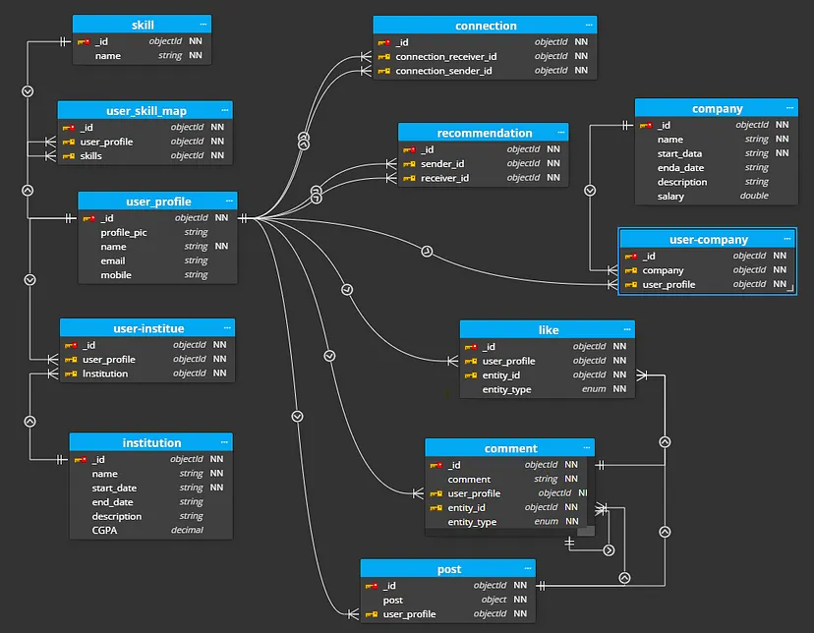

**Conclusion**

In this case study, we dived into the design of Linkedin's schema and Entity-Relationship diagram. Linkedin has revolutionised the way people approach to a company and how company approaches to a job seeker , fostering connections , the way of branding yourself and flexing your skills .The platform's intricate data model, consisting of entities like users, posts, comments, likes, connections and associations, forms the foundation for its seamless functionality. By understanding this schema, we gain knowledge about how Linkedin effectively manages the complexities of user interactions ,their content sharing , their connections , contributing to its widespread popularity and continued growth in the world of social platform.